|  |  |  |  |  |  |  |  |
| --- | --- | --- | --- | --- | --- | --- | --- |
| **1** | |  | **INTRODUCTION** | |  |  |  |
|  | |  | 1.1 Overview | |  |  |  |
|  | |  | 1.2 Purpose | |  |  |  |
| **2** | |  | **LITERATURE SURVEY** | |  |  |  |
|  | |  | 2.1 Existing problem | | |  |  |
|  | |  | 2.2 Proposed solution | | |  |  |
| **3** | |  | **THEORITICAL ANALYSIS** | |  |  |  |
|  | |  | 3.1 Block diagram | |  |  |  |
|  | |  | 3.2 Hardware / Software designing | | |  |  |
| **4** | |  | **EXPERIMENTAL INVESTIGATIONS** | | |  |  |
| **5** | |  | **FLOWCHART** | |  |  |  |
| **6** | |  | **RESULT** |  |  |  |  |
| **7** | |  | **ADVANTAGES & DISADVANTAGES** | | |  |  |
| **8** | |  | **APPLICATIONS** | |  |  |  |
| **9** | |  | **CONCLUSION** | |  |  |  |
| **10** | |  | **FUTURE SCOPE** | | **`** |  |  |
| **11** | |  | **BIBILOGRAPHY** | |  |  |  |
|  | |  | **APPENDIX** | |  |  |  |
|  |  | | Source code | |  |  |  |
|  |  | |  |  |  |  |  |
|  |  |  |  |  |  |  |  |

**Introduction:**

Ivaya Bistro is a responsive and most pertinent website for a restaurant. This website is a genuine platform with excellent and useful content which best fits a restaurant. It is an attractive and user friendly website which gives info about everything regarding the restaurant. It is has all the features and information which a customer wants to know before visiting a place.

The whole site is sub divided into different sections:

1. Home

This tab gives introduction about the restaurant and a contact us button. It describes the quality of ingredients picked. It also has Gallery and Reservation buttons. It further shows featured menus of the day. In the end we have description about Location Entertainment and Drinks.

1. Menu

Menu is sub-divided into Soups, Indian, Arabian, Italian, Chinese, Mexican, Desserts and Drinks, which on clicking particular button takes you to that page which has detailed information about those dishes along with the price of the dish. In the end we again have a Reservation button.

1. Reservation

Here we have report on how to book reservations. Address for online and Phone reservations and about the working hours. Further we have order from home option in this page.

1. Gallery

This page is special attraction for the website as it has description for Premier dishes. We have a contact us button here.

1. Contact Us

This page has the location details, address, phone number and e-mail address.

It also has a Search button with utmost accuracy.

**LITERATURE SURVEY**

**Existing Problem**

* The main problem which we face today is seat availability on a particular time
* The ambiance check for particular occasion.
* Is the food of our preference available?
* Reservation for a pre planned event.
* Number of cuisine available in a particular place.
* Unable to pre plan budget.
* Lack of Contact information of the place.

**Proposed Solution**

* Our website has answers to all of the questions above
* One can check for seat availability before coming to the restaurant.
* Can check our food description and ambiance in a detailed way on our website
* Can check if the food of our choice present on a particular day.
* Reservations for a pre-planned event are available
* We have all cuisines at one place with detailed description on our website
* Can have an approximate idea on the budget.

**THEORITICAL ANALYSIS**

**Block Diagram:**

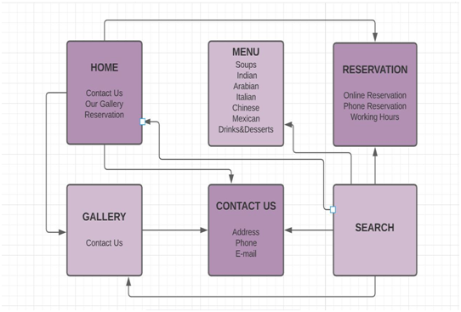

**Software and Hardware:**

**1.software:**

Theme used: Ocean WP

Plug-ins used: Ocean Extra and elementor .

**2.Hardware:**

64 bit Laptop

**EXPERIMENTAL INVESTIGATIONS:**

By interviewing many people from different age groups, different professions and random individuals we got to know that having a website for a restaurant would be really helpful in many ways.

It overcomes the problems of unavailable seats, incorrect guessing of prices and irrelevant place for different occasions.

**FLOWCHART:**

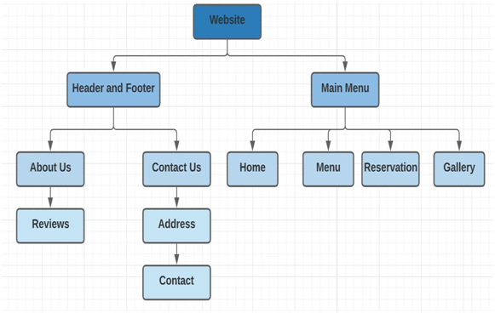

**RESULT:**

This is the final outcome of my website. This is a responsive and very user friendly website.

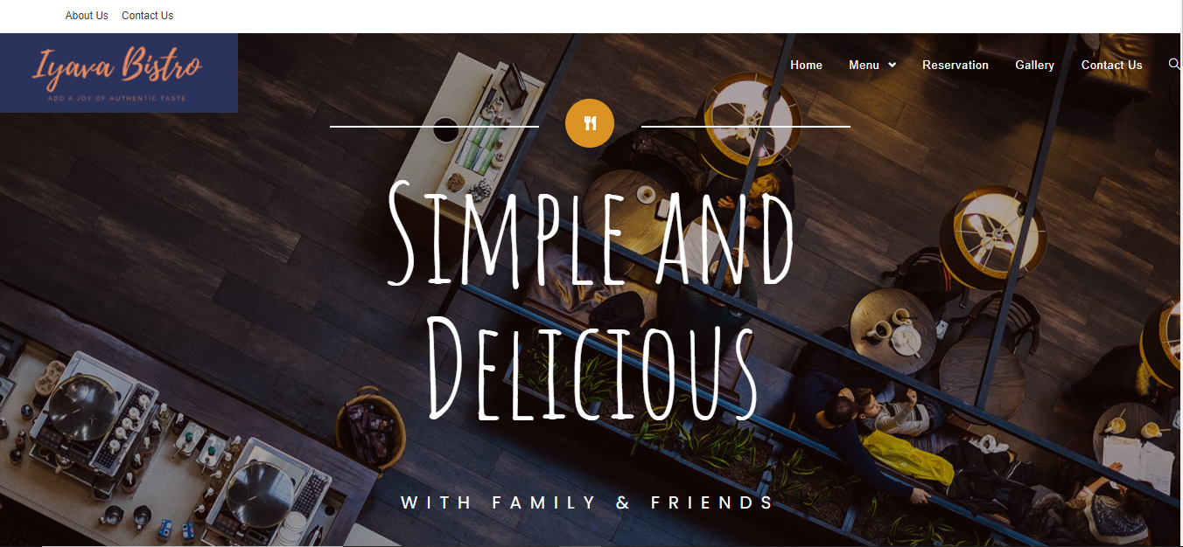

**ADVANTAGES & DISADVANTAGES:**

**Advantages:**

1. Reservations

This is the most helpful feature in the website because reserving a table without an online booking feature through phone would be very hectic and time taking process.

1. Ambiance check

This tab helps to pre check the place whether it suits your occasion or not

1. Preference of food

Every individual has different food preferences and having an online visible menu would help customers decide whether to choose this place on a particular day.

1. Seat availability

Sometimes we go to a restaurant with large group of friends/family and unfortunately many a times we have longer waiting periods to get seat for such a large group, so checking seat availability before coming to place would really save a large amount of time.

1. Location

This is useful to check the travel time and traffic in the way.

1. Accommodation for number of people

We can check how big the place is and the ambiance of the place through the gallery photos.

1. Budget.

The online menu helps us to decide the price for individual for lunch/breakfast/dinner.

1. All cuisines – one place

As Iyava Bistro has all cuisines at one place, the detailed information about this is given in the website

It is present on the internet and accessible to everyone.

**Disadvantages:**

The only disadvantage is one should have access to internet only then he/she can access the website and know about the website.

**APPLICATIONS:**

It has online presence round the clock

Information exchange between customer and management can be done easily

Customer can get insights about the place in an easy way

**CONCLUSION:**

Finally we can conclude that this website has various advantages to all type of customers by giving the information they need before visiting the actual place. I believe having an website to every restaurant makes life easier by saving time, effort and money.

**FUTURE SCOPE:**

As we know the online food ordering system is one of the most businesses. We can include this feature in future to our website. We also prevent missed orders due to busy phone lines or missed phone call. As the face of the restaurant industry is shifted from the traditional dine-in culture to takeaways, online ordering, and home deliveries. We can also incorporate mobile food ordering app in our restaurant management system to streamline the entire order taking process.

**BIBILOGRAPHY:**

I collected the food pictures from a website: https://www.freepik.com/

I referred to a few restaurant websites for reference for my website.